Connecticut Horse Council
February 4, 2025 Minutes - Highlights

FACEBOOK: Current information on Legislation, Events and Informative information goes up quickly. Diane, Carol and Ruth have been posting.
WEBSITE:
Rebecca Harnish updated several pages:
- Home – Welcome page - CHC Logo was placed on Front Page along with 2025 meeting dates
- News Alerts & Events Page – Events page -added DEEP No Child Left Inside Winter Festival, Added CT Horse 911 page with info on Horse Disasters, DART and downloadable emergency check lists links
- Publications – added the New CHC Brochure, December 2024 Meeting Highlights
- State Council & Laws – Legislation: updated link on Testifying at public hearings Zoning: added links from Equestrian Land Conservation Resource (ELCR), updated Links for CT Government Zoning Regulations List, (provided by Cory Iacino), and added the American Horse Council’s 2023 Economic Impact Study. Added Animal Health & Welfare page - Cathy Languerand will be submitting articles for this page.
Work still needs to be done:
- Home – Lauriann will check with web person on changing the home page picture along with pop up that say the site is not secure
- News Alerts & Events Page – Events page – CHC Annual Meeting & Open Huse needs to be up,
- CT Horse 911 – Danielle Borrelli will be submitting her CT Horse Fire Safety Power Point that will go up.
- State Council & Laws – Legislation: New 2025 Bills need to be added along with the link: Find Your Legislators. Zoning: Noelle Swan submitted the Power Point “Horses Make Good Neighbors” . Ready to be put up.
By-Laws: Update to change of meeting dates and times
- Publications –Winter Newsletter to be added to Equine Links: This is outdated and needs to be redone.
Add Links Horse Organizations to Businesses and with write up on their organization, website, Facebook page links, Add more CT related information such as Horse Therapy & Educational programs, etc.
- Trails – Volunteer Horse Patrol Program Book – Diane & Meg will work on updating it
- BY-LAW CHANGE VOTE: Change of scheduled meeting dates and times.
- Sponsors – Needs to be updated with new business members and organizations.
LEGISLATION: We are looking for volunteer(s) to monitor upcoming legislative bills that may affect the equine industry and then would notify CHC of the bill # and its contents, so that we can pass this on to our membership.

Please contact your legislators and ask them to SUPPORTS or OPPOSE on the following bills
Bill Information Search: https://www.cga.ct.gov/

Find Your Legislators - Connecticut General Assembly - CT.gov
How To Testify At A Public Hearing or Write your letter

Bills noted To Date:.
- Raised Bill No. 6440 - An Act Concerning the Organized Militia and Governor's Guards) for
AN ACT CONCERNING THE ORGANIZED MILITIA AND THE GOVERNOR'S GUARDS.
Statement of Purpose:
To enable the Governor's Guards to transition from the organized militia to a private military force.
Information on Underlying Bill: HB06440 (Chrome users: right click open in new tab)
Last Action: 1/24/2025 Public Hearing 0130
Sponsors: Veterans' and Military Affairs Committee
Committees: Veterans' and Military Affairs Committee
*(CHC COMMENT) - Vote to OPPOSE on this bill. See below for full bill - This removal of funding by the state will put the burden on the dedicated volunteers to raise funding to support this militia dating back to the 1700s. This action may possibly result in the ending of this historic tradition by defunding and abandoning these units. Our state should continue to maintain and strengthen these units instead of discharging them as part of the armed forces of CT. While these may be historical and ceremonial at this time, they do continue to provide community services. It is important to keep up our heritage and training of these volunteers. During emergency times these units can serve to help out in domestic emergencies with our National Guard units. During times when our National Guard units may be called out to serve other states or federal duty, we will have trained units to help support our citizens..
2. HB 5797 - AN ACT CONCERNING FUNDING FOR THE GOVERNOR'S HORSE GUARDS.
Statement of Purpose: To fully fund the Governor's Horse Guards.
Be it enacted by the Senate and House of Representatives in General Assembly convened:
That the sum of ____ dollars be appropriated to the Office of Policy and Management, from the General Fund, for the fiscal year ending June 30, 2026, for the Governor's Horse Guards.

Statement of Purpose:
To fully fund the Governor's Horse Guards.

Information on Underlying Bill: HB05797 (Chrome users: right click open in new tab)
Last Action: 1/22/2025 Referred to Joint Committee on APP
Sponsors: Rep. Hoxha, J. 078 ; Rep. Bolinsky, M. 106 ; Rep. Vail, K. 052
Committees: Appropriations Committee
*(CHC COMMENT) Vote to SUPPORT this bill. It is important to address this bill also in with you legislators at this time and ask them to Co-Sponsor this Bill to gain support for funding of the units.

3. Bill No. 5902 AN ACT CONCERNING THE BREEDING OF ANIMALS IN THE STATE.
January Session, 2025 LCO No. 1589 Referred to Committee on ENVIRONMENT Introduced by: REP. WOOD K., 29th Dist. Be it enacted by the Senate and House of Representatives in General Assembly convened: 1 2 3 4 5 6 That the general statutes be amended to prohibit the breeding of animals, including birds and reptiles, unless such person or company is registered with the Department of Agriculture. Additionally, to require the Department of Agriculture to create guidelines for the breeding of animals, develop a breeder registry, collect registration fees and perform annual inspections of such breeders. Statement of Purpose: To regulate animal breeding in the state through the Department of Agriculture.
New Federal Legislation: Horse Protection Act Horse Protection Act | Animal and Plant Health Inspection Service This a Federal law that prohibits sored horses from participating in shows, exhibitions, sales or auctions. It also prohibits the transportation of sored horses to or from any of these events.
OTHER bills pertaining to animals was emailed out to 20223-2024-2025 members with notice of this meeting
TRAIL REPORTS:
Diane Ciano Reports:
Vevette Greenberg, Meg Sautter, Denise Ciano & Randy Olmstead went out on the Larkin Bridle Trail to see what can be down at the Towantic Hill Rd. access/egress point which is badly eroded and dangerous and is causing users of the trail to trespass onto adjacent homeowners’ property. This trespass situation is beginning to cause additional problems. We don't want to lose access to this section altogether. (This section between Towantic Hill Rd. and Long Meadow Rd. is privately owned. DEEP cannot fix this problem due to the fact it is private property. CHC would like to help correct this situation and started a fundraiser for $1,000.00 for the material and discounted labor by All Green Hydroseed. Vevette also contacted the Private Land owner and Randy Olmstead got permission from him to access the property from the Long Meadow Rd. entrance property. We understand that we may have donations over the $1,000.00 we asked for and will be working on adding more material as need and possible swale to divert some of the water that runs onto the trail.
Two people have since come forward to say that they will pay any remaining Peter La Tronica owner of Lock Stock and Barrell in Bethany and a person by the name of Reeva.
Also, ShawnaLee Kwashnak donated Three 6x8" custom horse sketches in Charcoals each valued at $150 plus tax. As an incentive/thank you as to how we would want to give them out. Below is an example of her work.
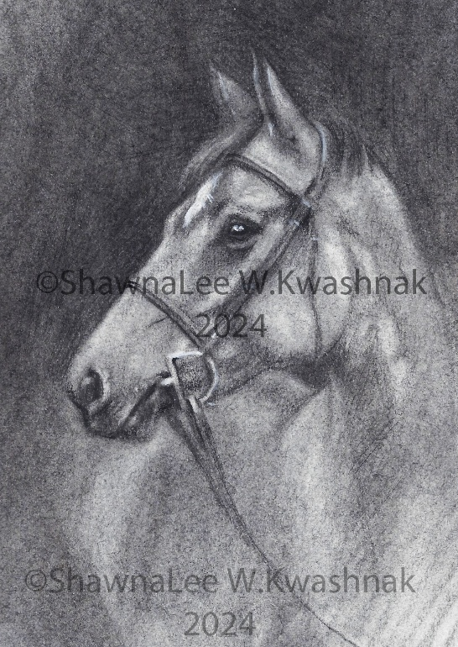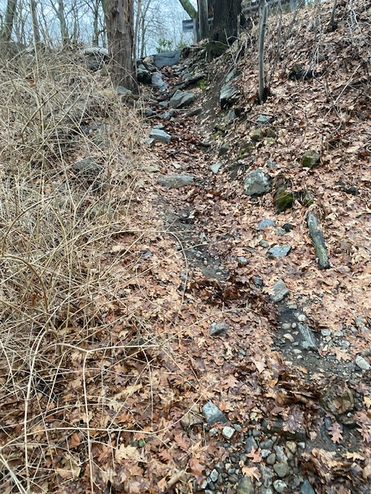
3 – 6”x8” of your horse or pet Towantic Hill Rd. access/egress point

Vevette Greenberg Reports:
A letter was written to the Town Selectmen, George Temple asking to meet with him regarding usage of a town owned land adjacent to the Larkin Bridle trail on Christian Rd., Oxford to be used for horse trailer parking and other users.

Meg Sautter Reports: Mono Pond State Park in Columbia: This is a new state a park and will connect will go into the Airline Trail. It is about 7 miles. I found that the trails were wet and muddy. You could get a 2-hour ride out there.
Denise Ciano Reports: A letter was written to her Senator Rob Sampson asking for his help to get appointed to the CT Equine Advisory Council.

Ruth Strontzer reports:
Cockaponset SF: CHC meeting was held at Cockaponset State Forest Headquarters in Haddam. DEEP Eastern District Supervisor Martin Torresquintero, Central District Supervisor, John Gugleilmoni, DEEP Greenways & Trails Coordinator, Kim Bradley Diane Ciano and Ruth Strontzer met to discuss topics and follow up on two previous meetings.
Topics covered: expanding horse trailer parking, improving current bridges on trails, trail etiquette signage and expanding horse camping in state parks and forests. The meeting went very well. In addition to ours, they were having a meeting later in the afternoon for first stage of a 5 yr General Management plan for horse camping at Machimoodus/ Sunrise State Park, that will also be used for other proposed horse camps in the state. They are planning on having a trail crew this spring and plan to address some of the bridge issues that were discussed. They will be looking at some of the locations we gave them and marked on maps for expanding parking for horse trailers and new locations in the Cockaponset State Forest. We will be having another meeting in the spring to visit the sites we noted on the maps. They are looking at a variety of signs for trail heads on trails and at kiosks including the Trails Safet Sign. Kim Bradley will have the signs available at the CHC-VHP Meeting on March 15th .

OUT REACH / EDUCATION:

No Child Left Inside Event:
Winter Festival at Burr Pond State Park – Denise Ciano, Diane Ciano and Cory Iacino were in attendance with 3 horses promoting the CT Horse Council, Volunteer Horse Patrol. There were 1,700 attendees !

Litchfield Hills Driving Club meeting - Diane spoke on the CHC at a recent meeting

CHC-Volunteer Horse Patrol Annual Meeting and Open House: Saturday, March 15th 10-2 Newington Fire House. DEEP Trails and Greenways Coordinator will be our Guest Speaker

ANIMAL WELFARE: Cathy Languerand is working on material for website

OLD BUSINESS: DEEP Survey: CHC needs an update as to how this survey went and if it is still ongoing.

NEW BUSINESS: Danielle is working on 2 Barn Fire Power Points - 1 for Horse Owners & 1 one for Fire Departments

CT GREENWAYS Council: Stacey Stearns has resigned from the Council serving 9 years.
We need to find another representative

CHC Meeting Dates: The next Meeting is April 1st, June 3rd, October 7th December 2nd at 6:30 pm – Eversource Community Room. 107 Selden Street, Berlin The public is welcome.

CT Equine Advisory: Thursday, March 20th - 6:30 pm – Eversource Community Room
107 Selden Street, Berlin The public is welcome.

